Kennedy Uzoho

CS 305

Module Five: Certificate Authority Generation

10/02/2022

* **Why would you want to use a CA for security?**

The Certificate Authority is an organization that provides secure encrypted communication between two parties over a network. CA ensures that a website is authenticated. A CA authenticates connections to ensure that website or a particular communication is authentic by verifying its SSL/TLS certificate. CA stores, issues, and signs a digital certificate access form. It is the root of trust that provides services that authenticate the identity of servers, computers, computer systems, websites, and other entities such as IoT.

* **What are the advantages of using a CA?**

CA provides trusted verification that ensures a system is securely connecting to another system by providing trust certificates. CA provides security for data in transit or between sources. A CA can help provide sensitive information about revoked or suspended certificates, helping users know which source to trust.

Certificate information form filled out with all fields completed

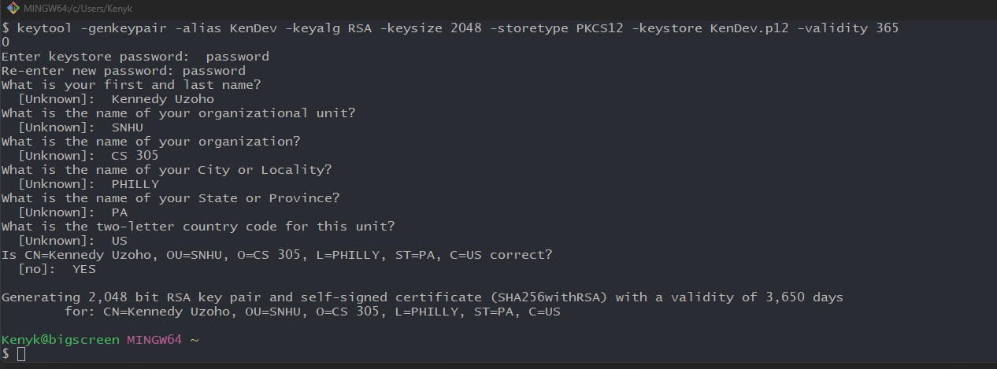

Command to export KenDev.p12 to certificate file server.cer



Screenshot of certificate file (server.cer) printed out

Reference

Crane, C. (2021, June 10). *What Is a Certificate Authority (CA) and What Do They Do?* Hashed Out by The SSL StoreTM. https://www.thesslstore.com/blog/what-is-a-certificate-authority-ca-and-what-do-they-do/#but-just-how-many-cas-are-there

IBM. (n.d.). *Benefits of Self-signed and CA-signed Digital Certificates*. IBM.Com. Retrieved October 2, 2021, from https://www.ibm.com/docs/en/b2b-integrator/5.2?topic=certficates-benefits-self-signed-ca-signed-digital-certificates

SSLSTORE. (n.d.). *What is an SSL/TLS Certificate? Here’s a Quick Overview*. SSLStore.Com. Retrieved October 2, 2021, from https://www.thesslstore.com/new-to-ssl/what-is-ssl-tls.aspx